**Git config command**

Git has 3 types of configurations.

--system – is system level configurations

–-global – is user level configurations

--local is project level configurations

Listing the options present under configurations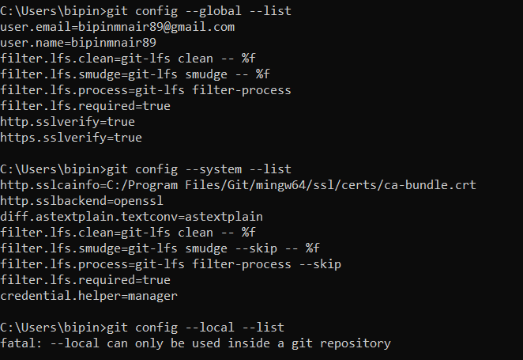

List the whole configurations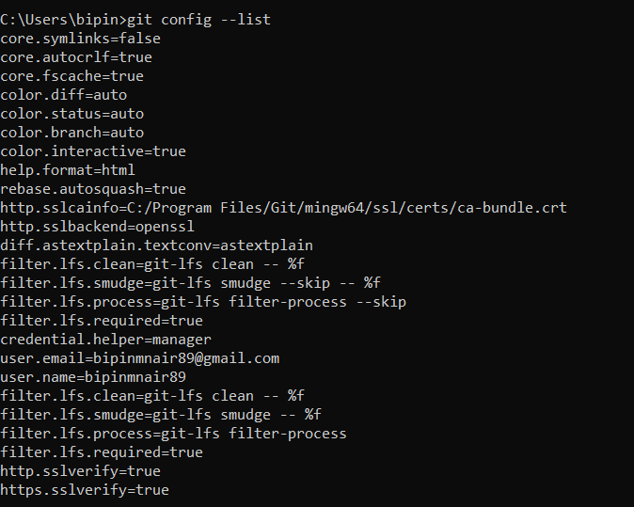

Trying to configure http.sslverify as false so that the project level issue – SSL certificate problem: Self signed certificate in certificate chain